QSuite 26x Minimum Hardware & Software Requirements

Contents
Disclaimer 2
Production Requirements 2
Network Infrastructure 2
Standard User Workstation Requirements 2
Scanning or Peripheral User Workstation Requirements (Dicta Phone, Signature Pad, EKG Device etc) 2
Peripheral Support 3
Device Interfaces 3
Hosting Deployment 4
Revision History 4

Disclaimer
The information provided in this guide pertains only to the documented software and hardware configurations as of its last update. Any software or hardware configurations not explicitly mentioned or covered in this guide are beyond its scope and should be approached with caution. We cannot guarantee the accuracy, reliability, or suitability of any undocumented configurations, and their use may result in unintended consequences, including system instability, data loss, or security vulnerabilities. It is essential to exercise prudence and seek advice from TRIARQ Health when dealing with any unmentioned software or hardware configurations. Additionally, we disclaim any liability for damages or issues arising from the use of such undocumented configurations. Remember that modifying software or hardware configurations beyond the official technical guidelines listed in this document may void warranties or support agreements with TRIARQ Health and/or with relevant vendors or manufacturers. Therefore, proceed at your own risk and take appropriate measures to safeguard your systems and data.

If there are any questions, please contact the TRIARQ Health’s Support team at incident@triarqhealth.com.

Production Requirements
Practices may choose to have TRIARQ host their QSuite application(s) in TRIARQ’s HIPAA compliant data center. Although this removes the need to have expensive servers on premises, there are still requirements which must be met for the local network infrastructure and equipment at practice. This document describes those requirements.
In addition, a local IT resource must be secured to perform the necessary local equipment set up and testing.

Network Infrastructure
- A dedicated fiber or business-class connection is strongly recommended for practices relying on RDP for clinical workflows.
  - For smaller practices less than 10-15 users consider 100-200 Mbps Down / 100-200 Up
  - For medium to large practices or smaller practices utilizing other QoS software, consider increasing this to upwards of 500 Mbps Down / 500 Mbps Up
Other Key Considerations:
  - Latency should be under 100 ms to TRIARQ Health’s Data Center (IPs listed below) for smooth RDP performance.
  - Use Quality of Service (QoS) to prioritize RDP traffic.
  - Recommendation to have two Internet Service Providers for Redundancy
  - Multiple Wireless Access Points may be necessary for a good connection to Wireless Devices
  - Port 22 (SFTP) should be opened and URL https://interface.triarqclouds.com should be whitelisted on the local firewall.
  - URL https://go.triarqclouds.com should be whitelisted on the local firewall.
  - Please whitelist the below IP Addresses
    - 35.225.226.16

Standard User Workstation Requirements
- CPU: Intel i5, i7 / 2.4 GHz Dual Core based processor with minimum 1 MB L2 Cache (SSE2 instruction set required).
- 16 GB RAM (32 GB RAM Recommended for Scanning and Heavy usage)
- 40 GB free hard disk space
- Gigabit network card
- Minimum 1440x900 screen resolution
- Windows 11 Professional

Scanning or Peripheral User Workstation Requirements (Dicta Phone, Signature Pad, EKG Device etc)
- CPU: Intel i5, i7 / 2.4 GHz Dual Core based processor with minimum 1 MB L2 Cache (SSE2 instruction set required).
- Minimum 16 GB RAM (32 GB RAM Recommended for Scanning and Heavy usage)
- SSD Hard Drive
- 40 GB free hard disk space
- Gigabit network card
- Minimum 1440x900 screen resolution
- Windows 11 Professional or higher

Peripheral Support
The number of certified peripherals for use with RDS servers continues to grow. Here are the current statuses of peripheral support:

Device Type | Notes
Printers | All printers compatible with Microsoft
Document Scanners:  - Fujitsu 7160 series or higher  - Brother ADS-3000N or higher  - Kodak i2000 series, Kodak i2800 or higher  TRIARQ Health does not guarantee that all scanners with a TWAIN driver will function as intended, except for those which have been tested above. | - LDS Service needs to be installed on the local client machine (software provided by TRIARQ Health)  - Recommended 300 DPI scanning w/ lossy compression setting set to 50%  - Document scanners must have a TWAIN driver available and installed for the scanner to be compatible.
Card Scanners:  - ScanShell 3100D / DN or higher | - Only base image scans are supported
Microphones:  - Depends on the solution being used. | - Nuance Dictaphone PowerMic II  Dragon Client for Remote Desktop must be installed on machine for button mapping. (ONLY software provided by TRIARQ Health)  - Press-to-talk capabilities not supported; simple toggle on / toggle off microphone only supported.  - Remote Desktop Connection - ‘Record from this  computer’ option set in ‘Remote Audio’ options
Signature Pads:  - Topaz USB T-LBK462-HSB-R / BSB-R | - LDS Service needs to be installed on the local  client machine (software provided by TRIARQ Health)
Web Cameras | - Any Microsoft Windows supported web cam  - Requires glo Cam Capture utility (software provided by TRIARQ Health)

Device Interfaces
Device Type | Notes
- Vital machines, ECGs, EKGs, etc. | - Available on a case-by-case basis  - Additional costs may apply

Hosting Deployment
The following model illustrates a basic TRIARQ Hosting deployment. In this model, all QSuite software is securely stored in TRIARQ’s
secure data center.

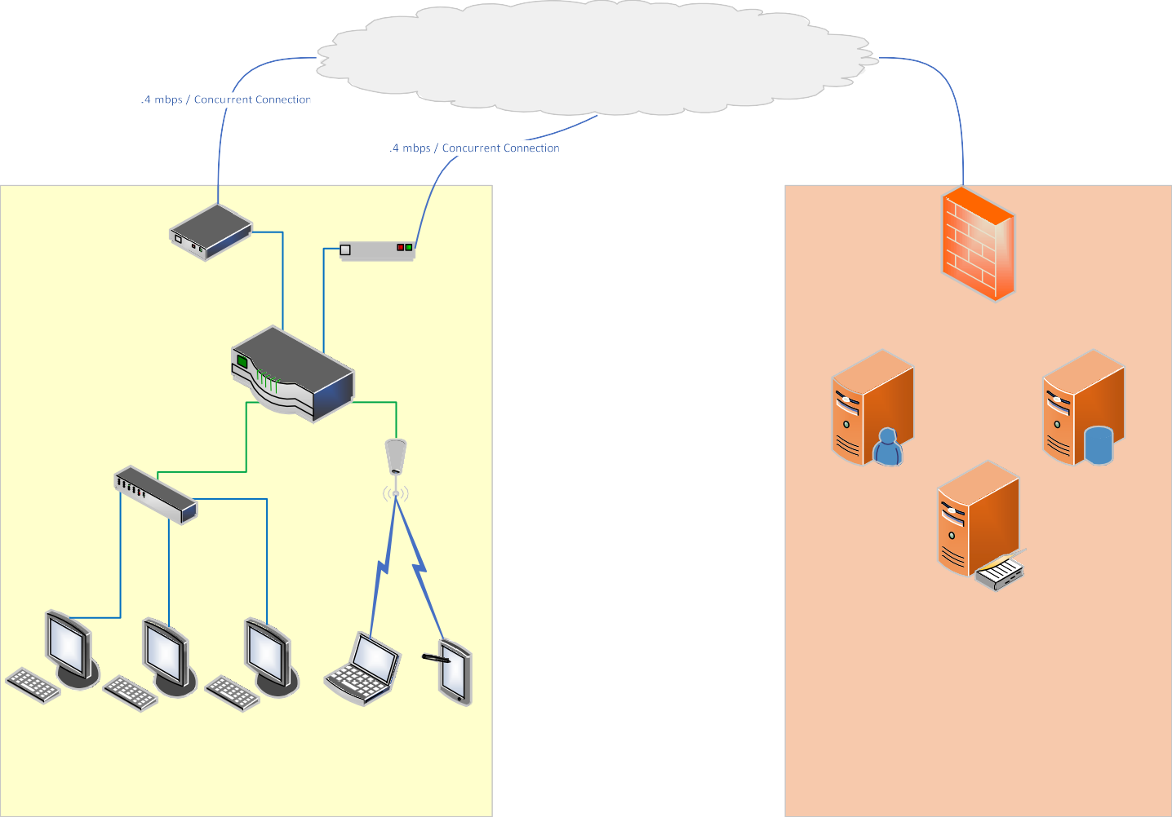
Data Center Firewall
Terminal
Server
Database
Server
Active Directory
Server
TRIARQ Secure Data Center
Internet Cloud
Cable Modem
DSL, T1, etc...
Dual WAN Router
Cisco RV042 Cisco RV082
Netgear FVS336Gv2 Etc...
Sample Practice Configuration
Practice Network Infrastructure Requirements:
Refer the section
Network Infrastructure

Revision History

Date | Authored/Reviewed by | Ver. | Notes
7/20/2023 | Gajanan Anturkar | 1.0 | Updated Initial draft
7/20/2023 | Jon Kramer | 1.0 | Reviewed & revised
4/2/2025 | Jon Kramer | 2.1 | Reviewed & revised
4/15/2026 | Aniket Tamhane | 2.2 | Reviewed & revised

